PROFHILO®

NEW AND INNOVATIVE ANTI-AGEING, FACIAL REJUVENATION AND SKIN TIGHTENING TREATMENT
PROFHILO® is one of the most advanced medical aesthetic treatments and is approved for cosmetic use in many countries, including the UK. This revolutionary treatment can provide you noticeable facial skin rejuvenation and anti-aging results in just 2 sessions.

WHAT IS PROFHILO®?

Profhilo® is the first BDDE-free stabilised injectable hyaluronic acid (HA) based product for treating skin laxity.
With one of the highest concentrations of HA on the market (64mg / 2ml) it is not only boosting and hydrating the skin, but also remodels the ageing and sagging tissue.

What can PROFHILO® do for you?

PROFHILO® is used to regenerate Collagen and Elastin in the skin and give you:
- Plumping effect
- Increased elasticy
- Soft tissues treatment
- Lifting effect
- Re modelling
- Redefinition
- Tissue regeneration

Some examples of before and after Treatment- (not our own patients)

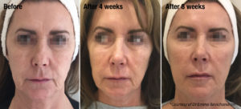
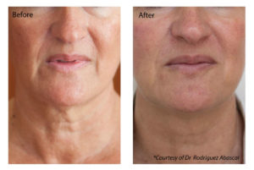
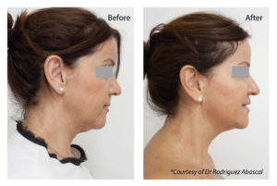
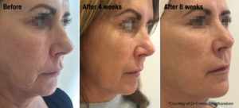

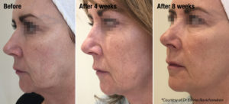
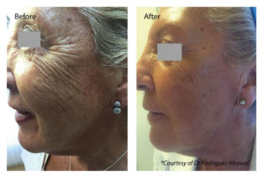

WHICH AGE IS INDICATED FOR PROFHILO®?
30-50 years. But it is also effective with some younger and older patients.

How is PROFHILO® treatment administered?

PROFHILO® is an injection that your practitioner will give you that can be used on the FACE, NECK, BODY.

How long does PROFHILO® injection last for?

While every patient is different and result duration will vary, usually, the effects from PROFHILO® will last from four to six months.
Many patients who use PROFHILO® regularly experience that their results will show for longer if they are consistent with their PROFHILO® application.

How long does it take to see the benefits from PROFHILO®?

After 3-4 days, but the full effect can be seen after one week. In some patients the improvement is not visible after one treatment: for this reason, we suggest 2 treatments.

How long do the PROFHILO® effects last and what happens it after this?

PROFHILO® has a longer lasting effect and this varies in different people as it depends on age, skin type & quality, the area being treated individual lifestyle.

Who can use PROFHILO®?

PROFHILO® is suitable for most people. However, PROFHILO® should not be used in or near areas where there is or has been a skin disease, inflammation or skin related problems.
PROFHILO® has not been tested in pregnant or breastfeeding women, individuals with medical conditions that lower the body’s immune response. Individuals undergoing immunosuppressive therapy may be more prone to infection by a skin injection procedure.
When is PROFHILO® not recommended?

While PROFHILO® is quite safe, it’s used is not indicated for patients who are:
- Pregnant
- Breast Feeding
- Allergy
- Immunocompromised

Are the PROFHILO® injections painful?

PROFHILO® is injected with a very fine needle and cause minimal discomfort.

Does PROFHILO® Cause Swelling?

When PROFHILO® is injected correctly in the suggested injection layer and in the suggested area there is usually minimal swelling. However, there is always a risk of swelling, bruising and allergic reaction with any injected medicine. You will have little blebs or bumps at the injection sites for 24 hours after treatment, but these will disperse as the product disperses.
We recommend not having treatment if you have an important event in the next 2 weeks should any bruising or swelling be unacceptable.

What Should I Tell My Practitioner Before Having PROFHILO®?

It is highly recommended that you tell your practitioner about all your medical conditions, including if you:
- Have a disease that affects your muscles and nerves
- Have or have had a breathing problem, such as asthma or emphysema.
- Have or have had swallowing problems
- Have or have had bleeding problems.
- Have plans to have surgery.
- Had surgery on your face.
- Have weakness of your forehead muscles, such as trouble raising your eyebrows.
- Have drooping eyelids.
- Have any other change in the way your face normally looks.
- Treated areas shouldn’t be reinjected within 2 weeks of the initial procedure.

Guidelines for timing with other treatments.

- Botulinum toxin: two weeks prior.
- Microdermabrasion, chemical peel, IPL: 1–2 weeks pre or post treatment
- Fractional resurfacing 3–4 weeks distant
- Treatment should not be undertaken in the immediate period following other routine medical procedures (including vaccination).
- Dental procedures: at least 2 weeks pre or post treatment
- Are pregnant or plan to become pregnant. It is not known if PROFHILO® can harm your unborn baby.
- Are breastfeeding or plan to breastfeed. It is not known if PROFHILO® passes into breast milk.

Are there any side effects?

Some undesired effects which may appear at the injection site are pain, sensation of heat and reddening or swelling (as listed in the package insert). These generally disappear in a short period of time.
The injection point on the zygomatic protrusion(cheek) may disappear more slowly than the others (up to 1-2 weeks).

Contraindications for PROFHILO®

Please do not use PROFHILO® in these cases:
- Allergies to product ingredients
- Allergies to Gram +ve bacterial proteins or lidocaine.
- Infected skin area e.g. cold sores, acne

- Cautioned use is advised when taking anticoagulants due to increased risk of bruising.

Post PROFHILO® Treatment Recommendations

In order to assure that your treatment is successful, and you get all of its benefits, please follow these recommendations:
• Use a cold pack to reduce swelling and/or redness.
• Do not apply makeup or creams on the day of treatment, then after 24 hours you can use makeup to cover any redness or bruising.
- Eating fresh pineapple or arnica tablets can be consumed to help reduce bruising or apply arnica gel.
- Regular antihistamines for the first 24-48 hours

Things to avoid:

- Physical strain and sports on the first day after the treatment
- Further cosmetic therapies for the first 2 days after treatment.
- Sauna, steam bath, icy temperatures or UV radiation by the sun or a solarium for two weeks after the treatment.
- Try to stay hydrated (1.5-2.0 litres water per day)

